Project Question: Can travel tell us about the policy trajectories of public figures?
Much has been made about changing policy directions under new administrations and travel data presents a novel way to explore these differences through a visual medium. In this case, our team (consisting of Luyun Shao and I) decided to scrape publicly available travel records kept by Chinavitae for Hu Jintao and Xi Jinping to see what could be observed about their domestic and foreign policies.

To do so, we first began by creating a biography wheel which allows users to see the paths each leader took to get to their positions.
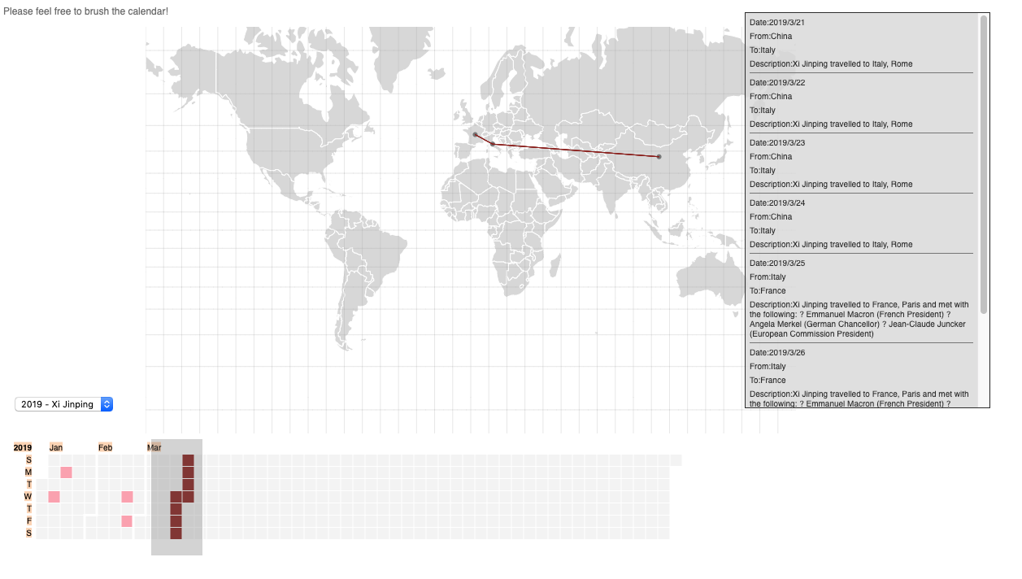
Thereafter, we looked at international travel data. Here, we looked at the ratios between the number of times foreign leaders visiting China to meet with a Chinese president against the number of days spent by these Presidents visiting other countries. We then proceeded to do a deeper dive into the types of countries visited during their tenure, extracting the top 10 to see if there were any discernible differences in travel priorities. Taking inspiration from the hour-glass structure mentioned in Segel and Here (2010), we created an interactive web map for users to see the travel patterns of the Presidents for a sample of the years.
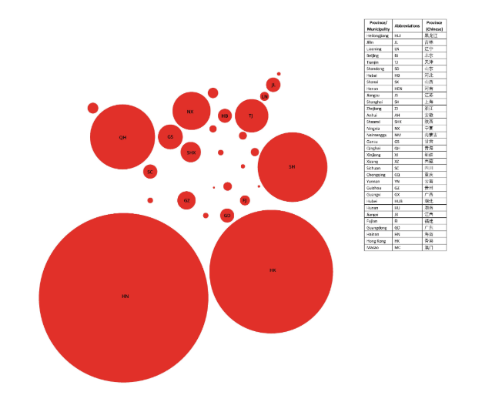
We next moved on to domestic data to investigate if the importance of provinces have shifted relative to the rule of the Chinese leaders. To do so, we cleaned the data to obtain travel counts to each province and then weighted the importance according to the inverse of the number of visits per 10 000 000 residents as radii.

Code links and cleaned data is made available for download via our Githubs.

